**A Crm Application To Handle The Clients And Their Property Related Requirements**

**Team Members:**

Team Naan Mudhalvan ID: NM2024TMID17229

**Kuyilan S** (712521104016)

BE. Computer Science and Engineering,

NM Mudhalvan ID: au712521104016

PPG INSITUTE OF TECHNOLOGY, COIMBATORE.

**Nithishkumar T** (712521104026)

BE. Computer Science and Engineering,

NM Mudhalvan ID: au712521104026

PPG INSITUTE OF TECHNOLOGY, COIMBATORE.

**Sasikumar R** (712521104041)

BE. Computer Science and Engineering,

NM Mudhalvan ID: au712521104041

PPG INSITUTE OF TECHNOLOGY, COIMBATORE.

**Janani T** (712521104010)

BE. Computer Science and Engineering,

NM Mudhalvan ID: au712521104010

PPG INSITUTE OF TECHNOLOGY, COIMBATORE.

SL NO. TASK

1. Create a Jotform and integrate it with the org to create a record of

customers automatically.

1. Create Objects from Spreadsheet.
2. Integrate Jotform with Salesforce Platform
3. Create Roles
4. Create a Property Details App
5. Create Profiles
6. Create a CheckBox field on user
7. Create Users
8. Create an Approval Process for Property Object
9. Create a Record trigger flow to submit the Approval Process

Automatically.

1. Create an App Page
2. Create a LWC Component
3. Drag this Component to your App Page
4. Give Access of Apex Classes to Profiles

**Jotform**

**Task 1: :- Create a Jotform and integrate it with the org to create a record of customers automatically.**

**Objective**: Create a form to capture customer details automatically and create a record in Salesforce.

● **Activity**:

a. Develop a JotForm to capture details such as Name, Phone, Email, Address, and the type of property the customer is interested in.

**MyForm**: https://form.jotform.com/243242126483048'

**Task 2:**

**Objective:**

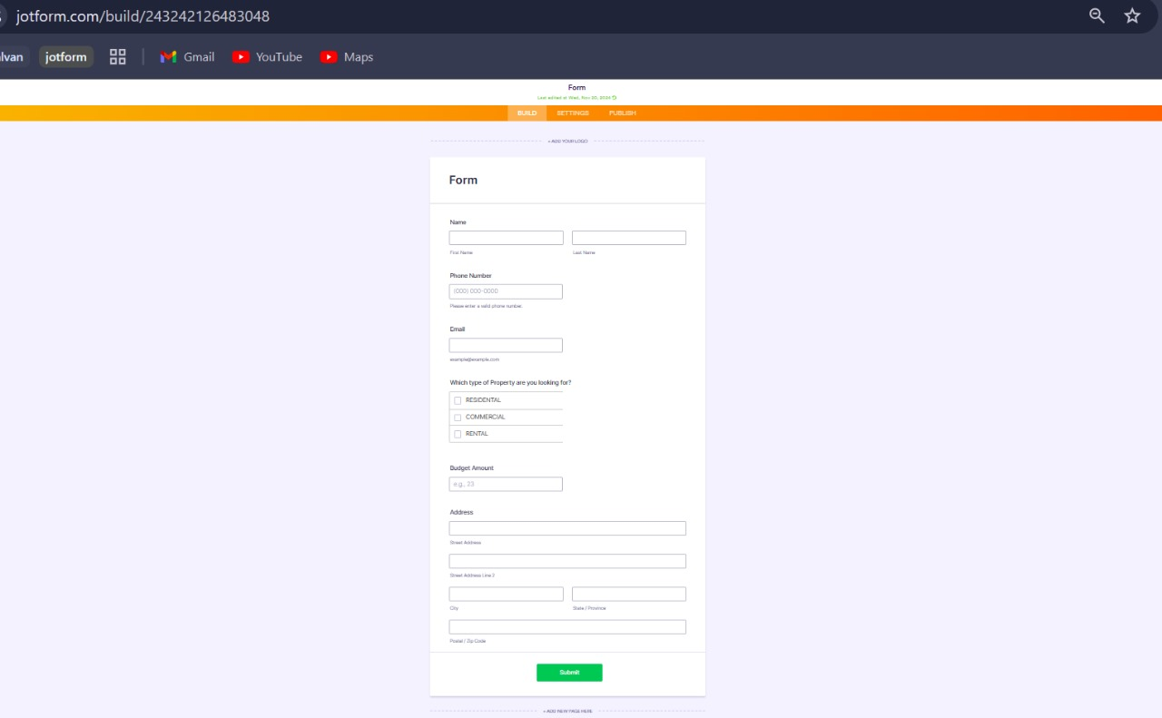

**Task 3: Create Objects from Spreadsheet.**

Directly create objects in Salesforce from a spreadsheet.

**Activity**:

**Objective:**

**Task 3:**

1. Create Customer object

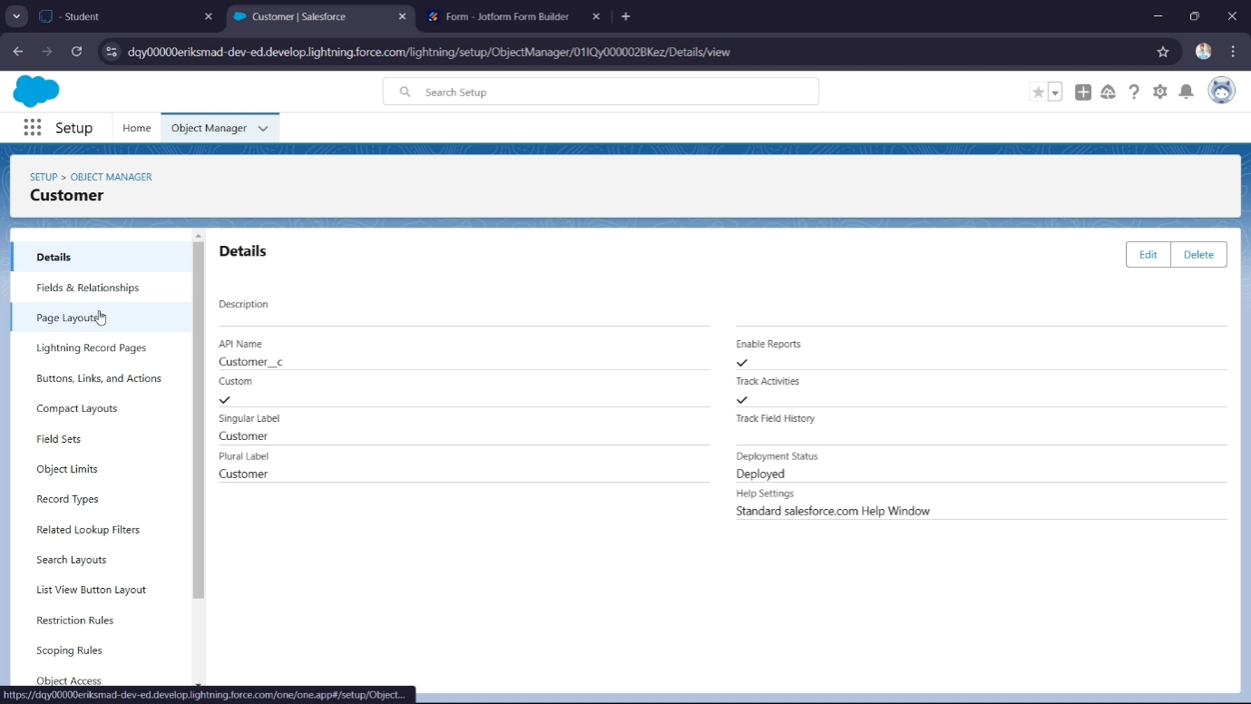

B.Create Property object:

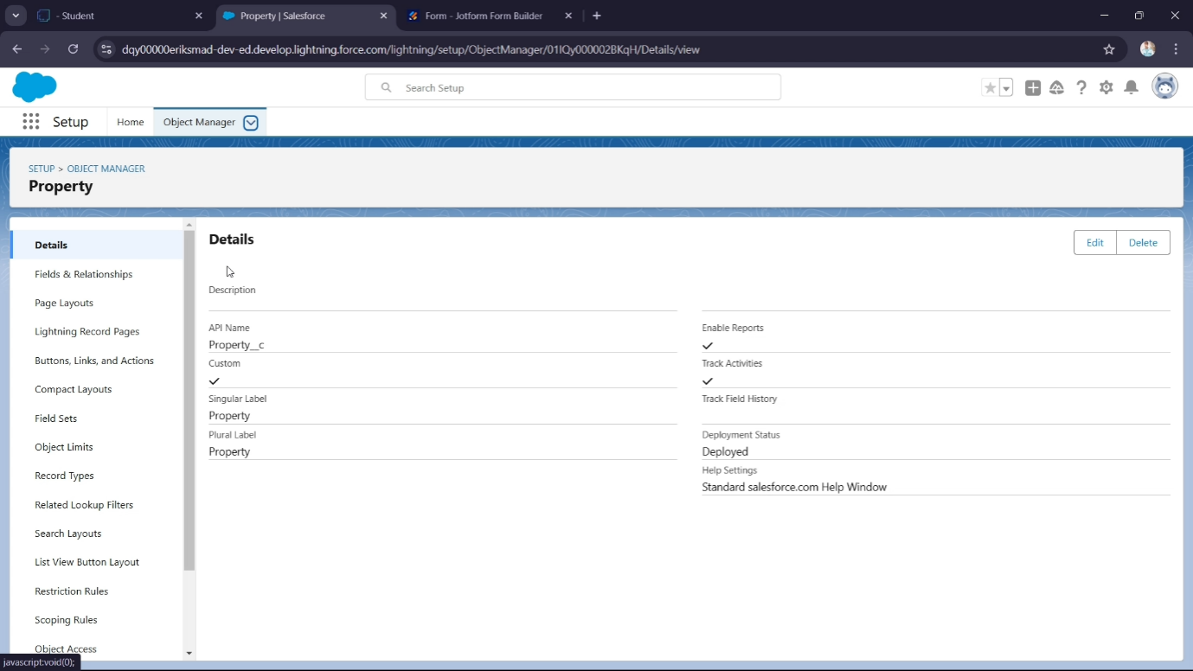

**Integrate Jotform with Salesforce Platform:**

Integrate JotForm with Salesforce to create customer records automatically.

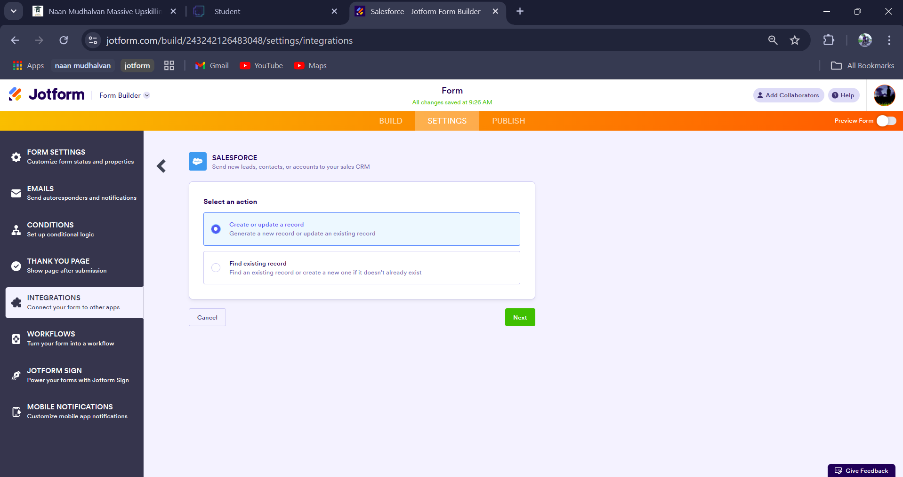



**Create Roles:**

Create roles as per the business requirements.

**Activity**:

1. Establish a hierarchical role structure where Sales Managers report to Sales Executives.
2. Establish a hierarchical role structure where Customer report to Sales Managers

**Task 4:**

**objectives:**

**Sales Executive Role:**

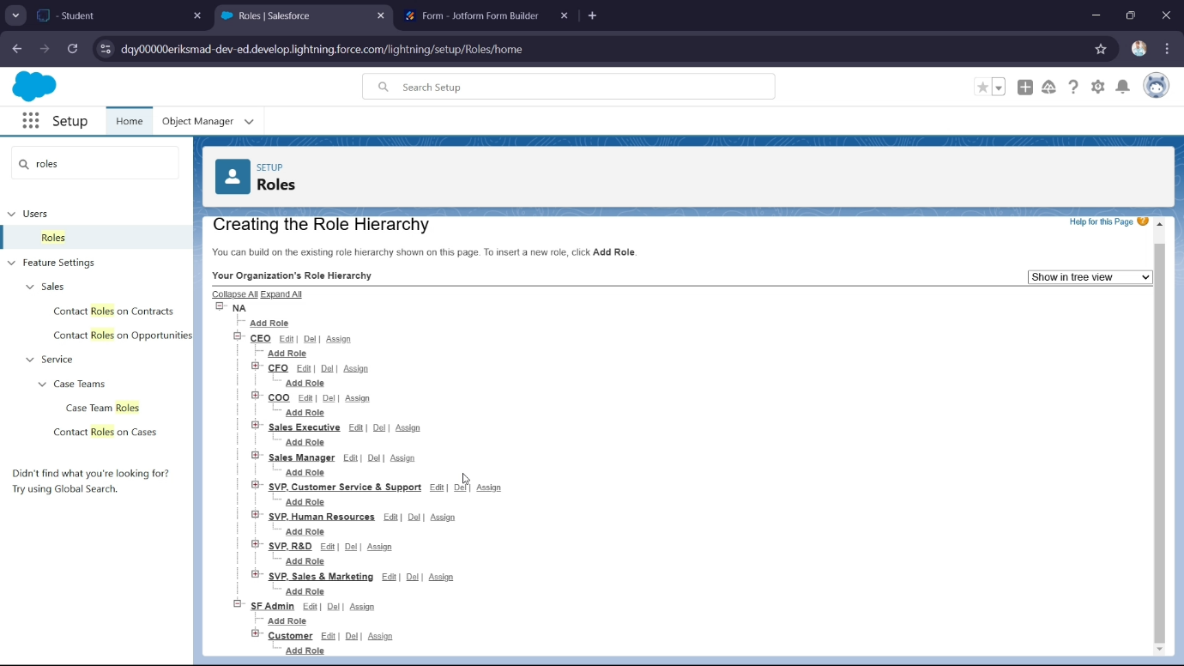

**Task 5: Create**

**Objective:**

**Activity:**

### a Property Details App

Create an app to display the created objects.

a. Create a new Lightning App named "Property Details" and add Customer and Property objects.

**Create a Property Details App**

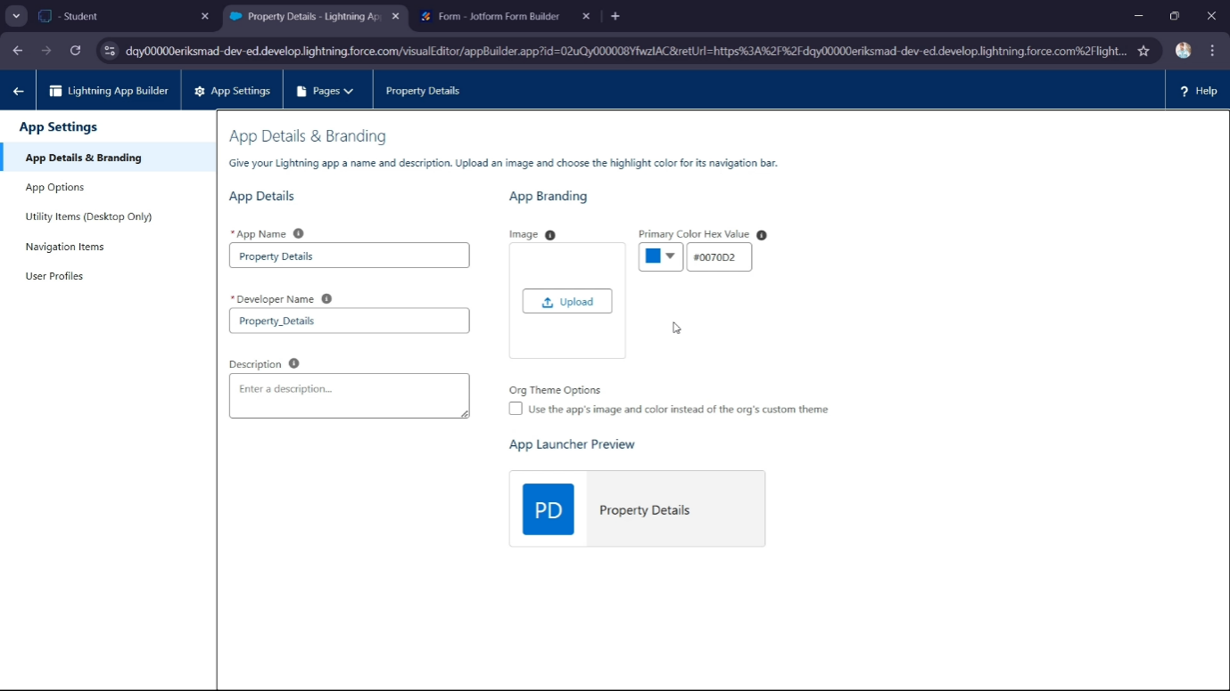

**Create Profiles**

**Customer:**

### Profiles

Set up profiles as per the business requirements.

1. **Customer Profile**: Clone the Salesforce Platform User profile, name it "Customer," and adjust custom app settings to include only Property Details.

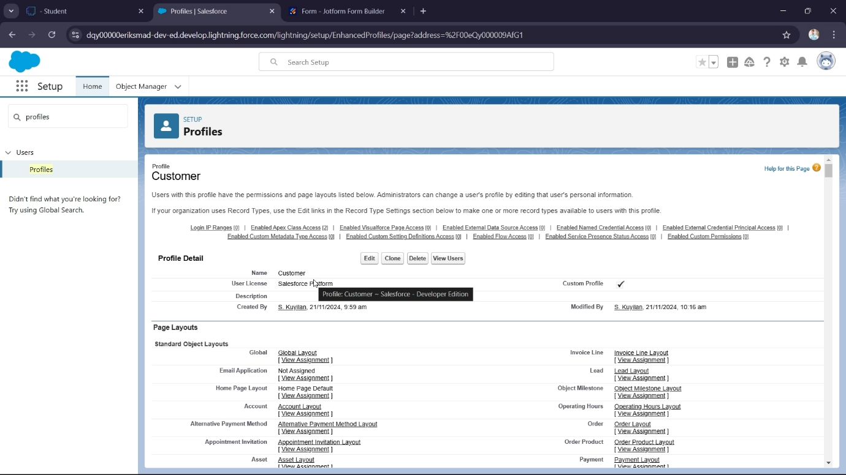

1. **Manager Profile**: Clone the Salesforce Platform User profile, name it

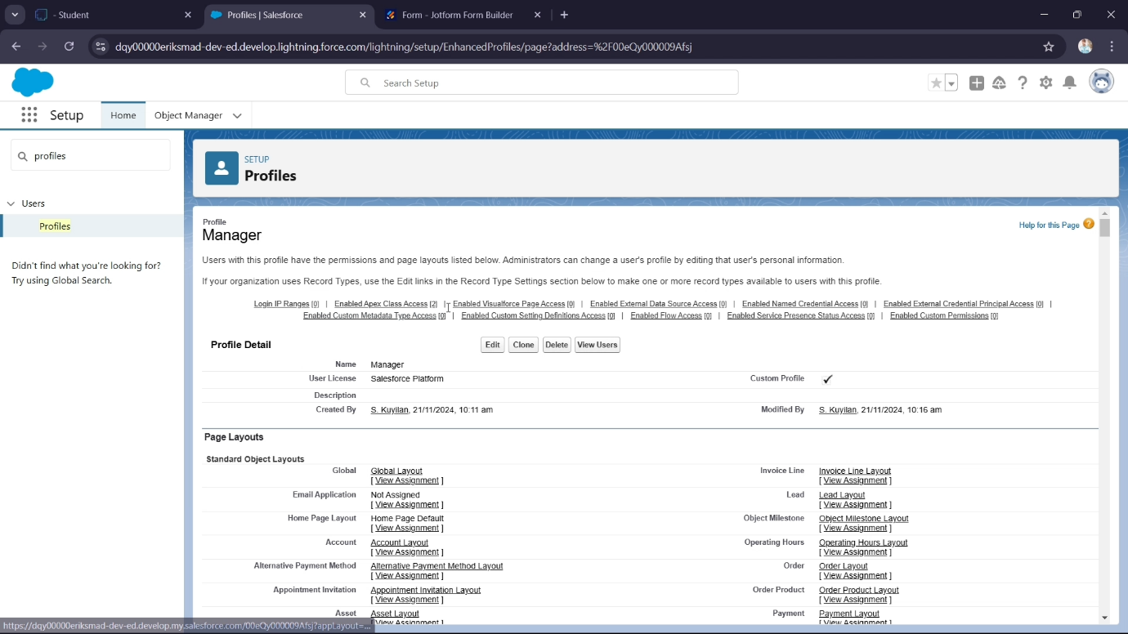

**Create a Check Box field on user**

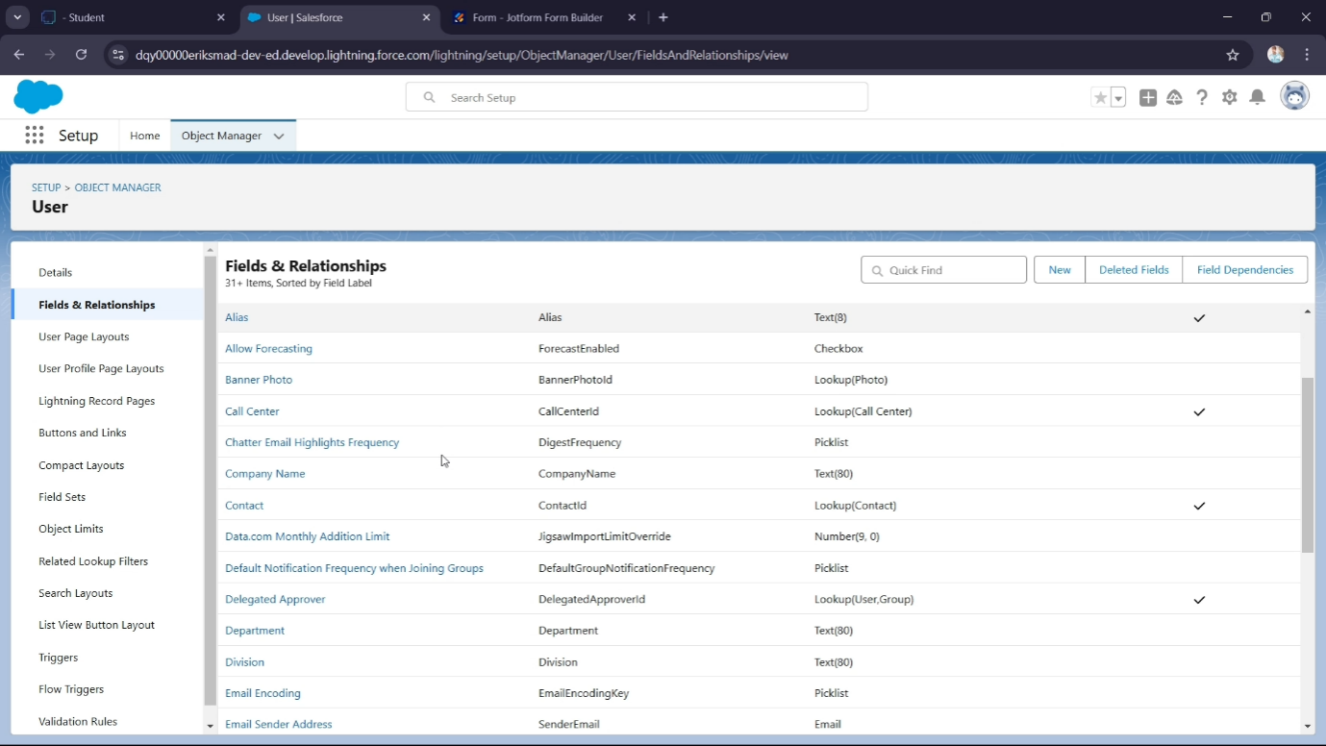

**Task 6:Create Users**

**Objective**: Create users with different roles and profiles.

● **Activity**:

1. **User 1**: Sales Executive with the System Administrator profile.

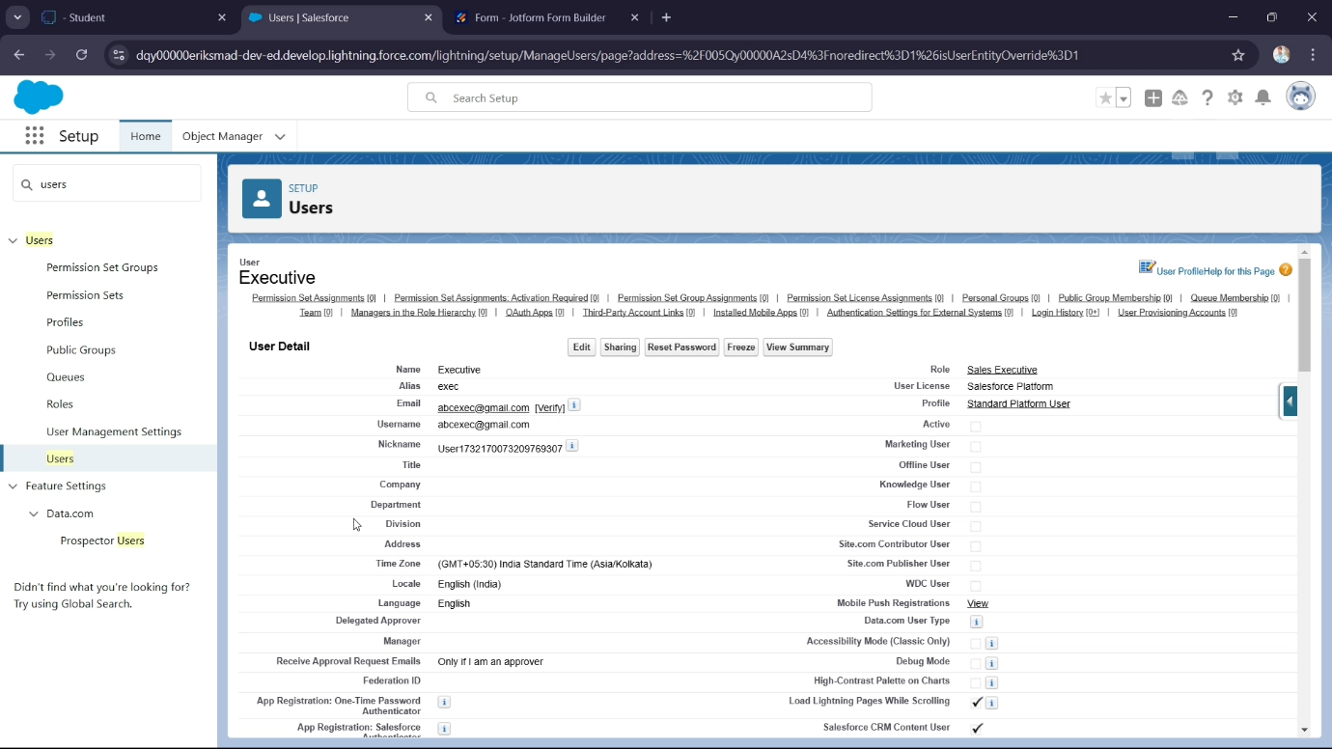

1. **User 2**: Manager with the Manager profile.

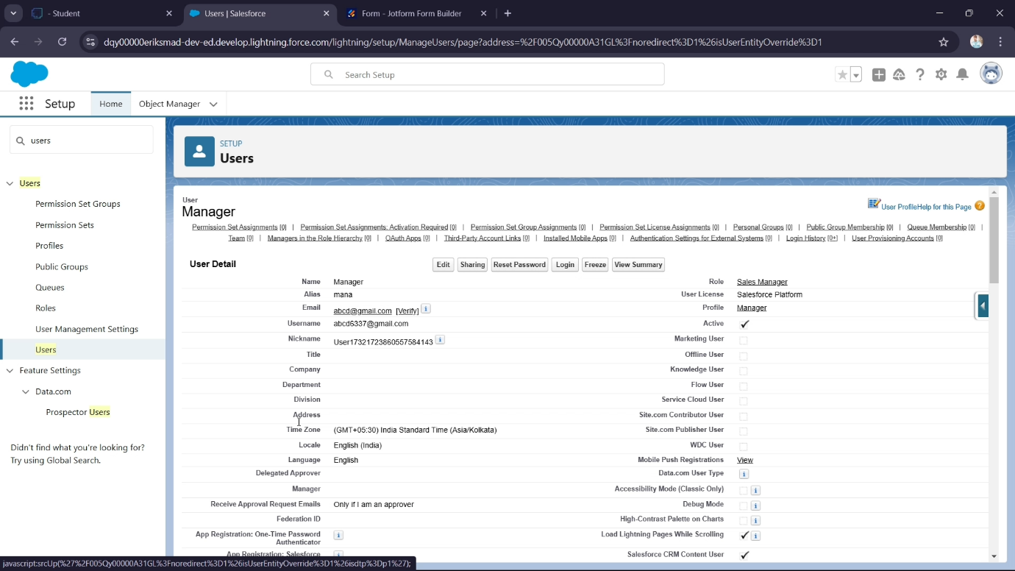

1. **User 3**: Customer with the Customer profile, "Verified" checkbox unchecked.

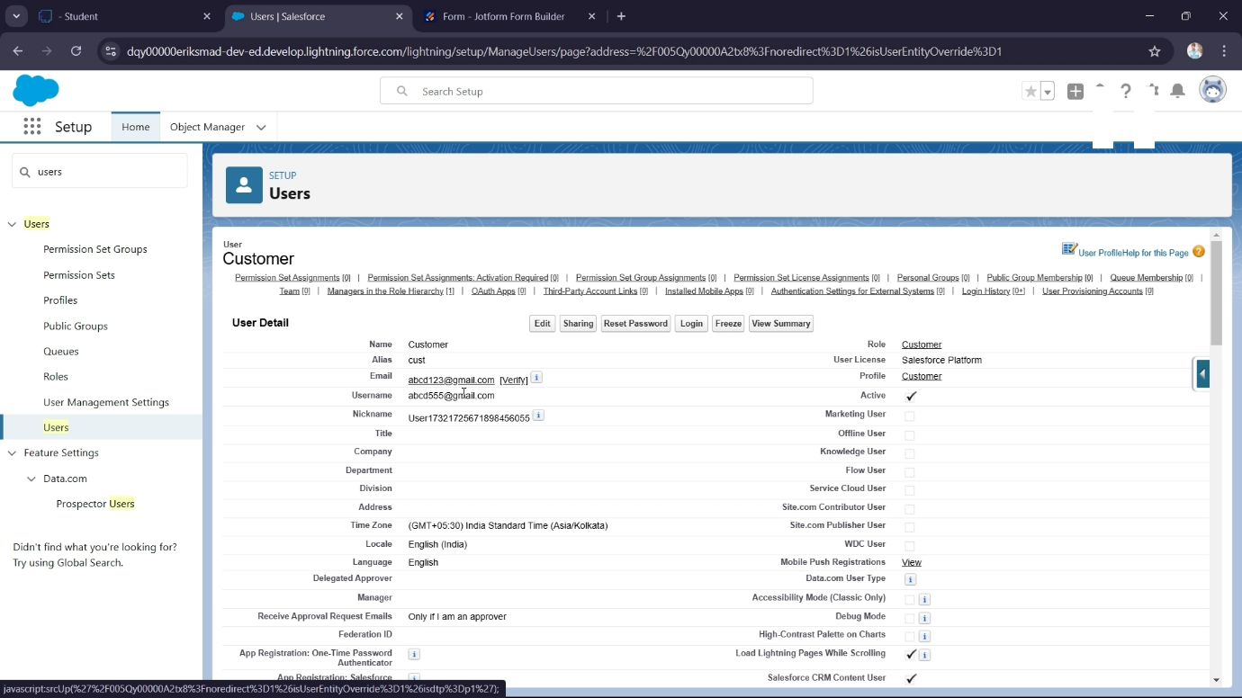

1. **User 4**: Customer2 with the Customer profile, "Verified" checkbox checked.

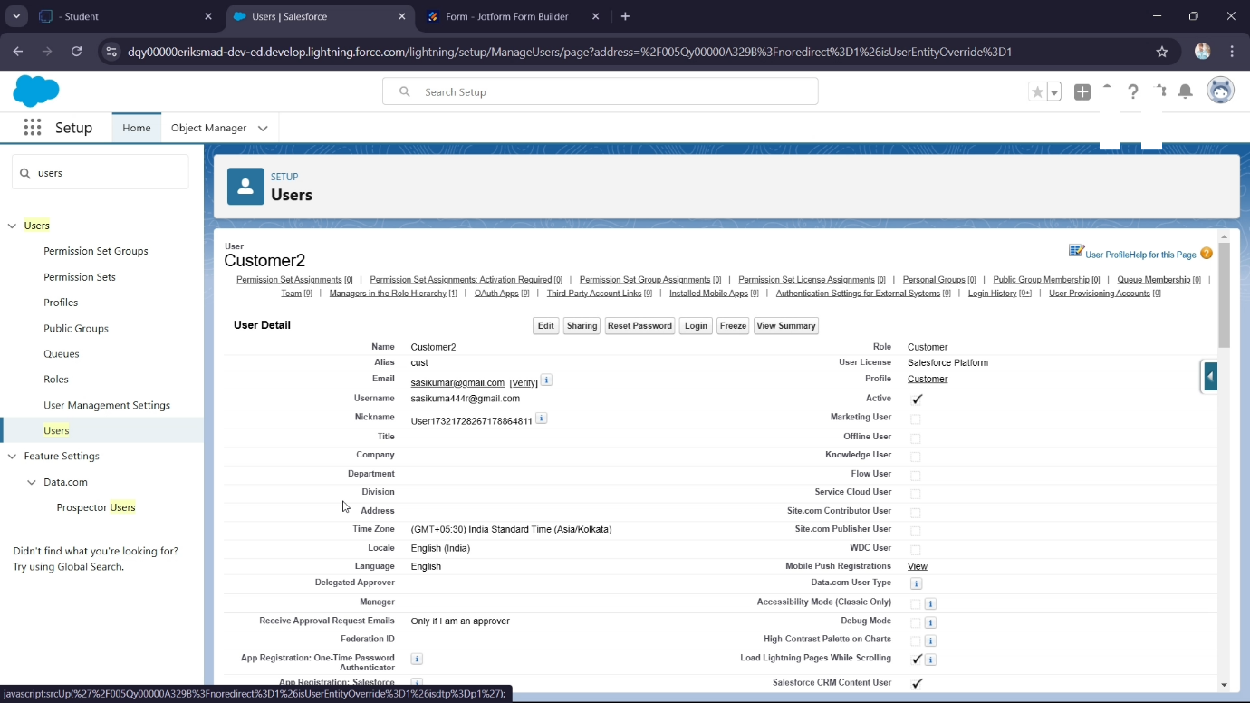

**Task 7: Create an Approval Process for Property Object**

**Objective**: Establish an approval process for the Property object.

● **Activity**:

a. Create a "Property Approval" process with criteria such as "Location is not blank" and "Verified equals false." Assign Managers and Sales Executives as approvers, and update the Verified status based on approval outcomes.

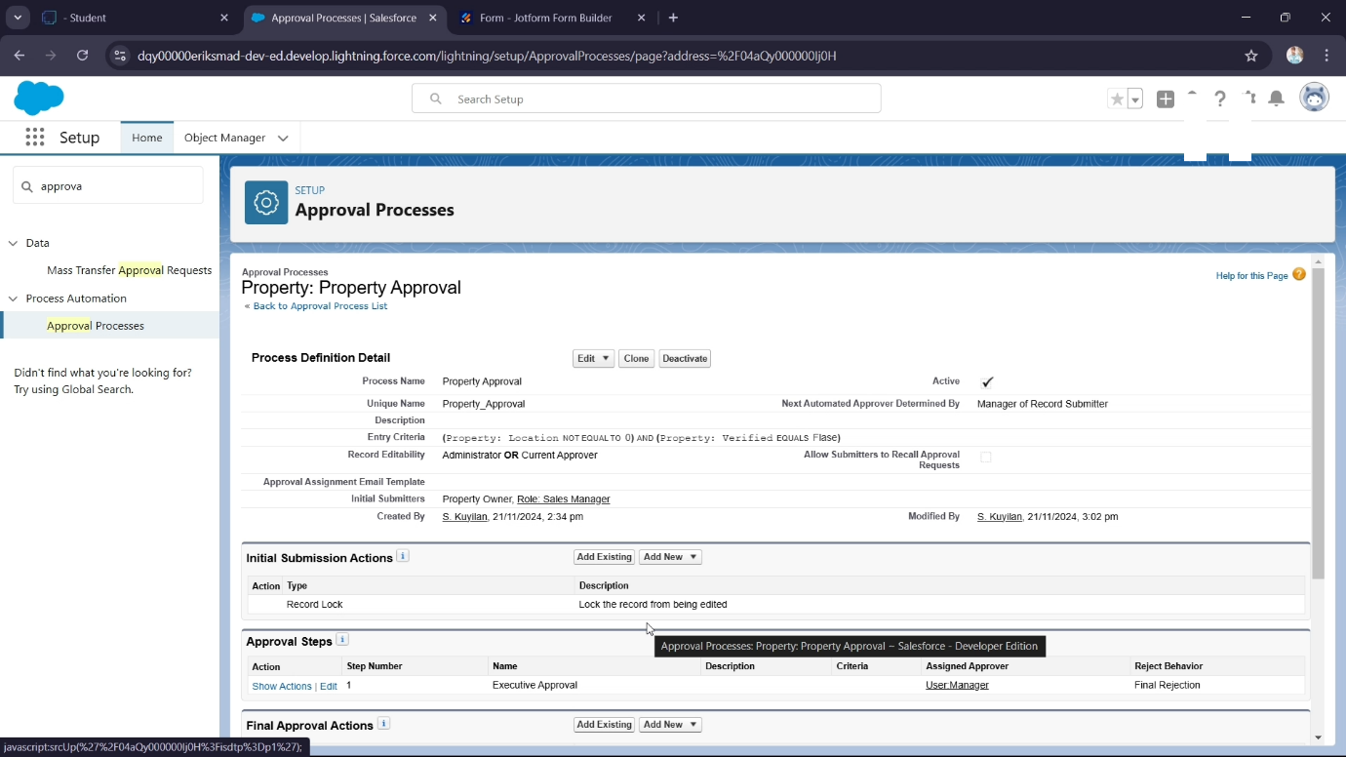

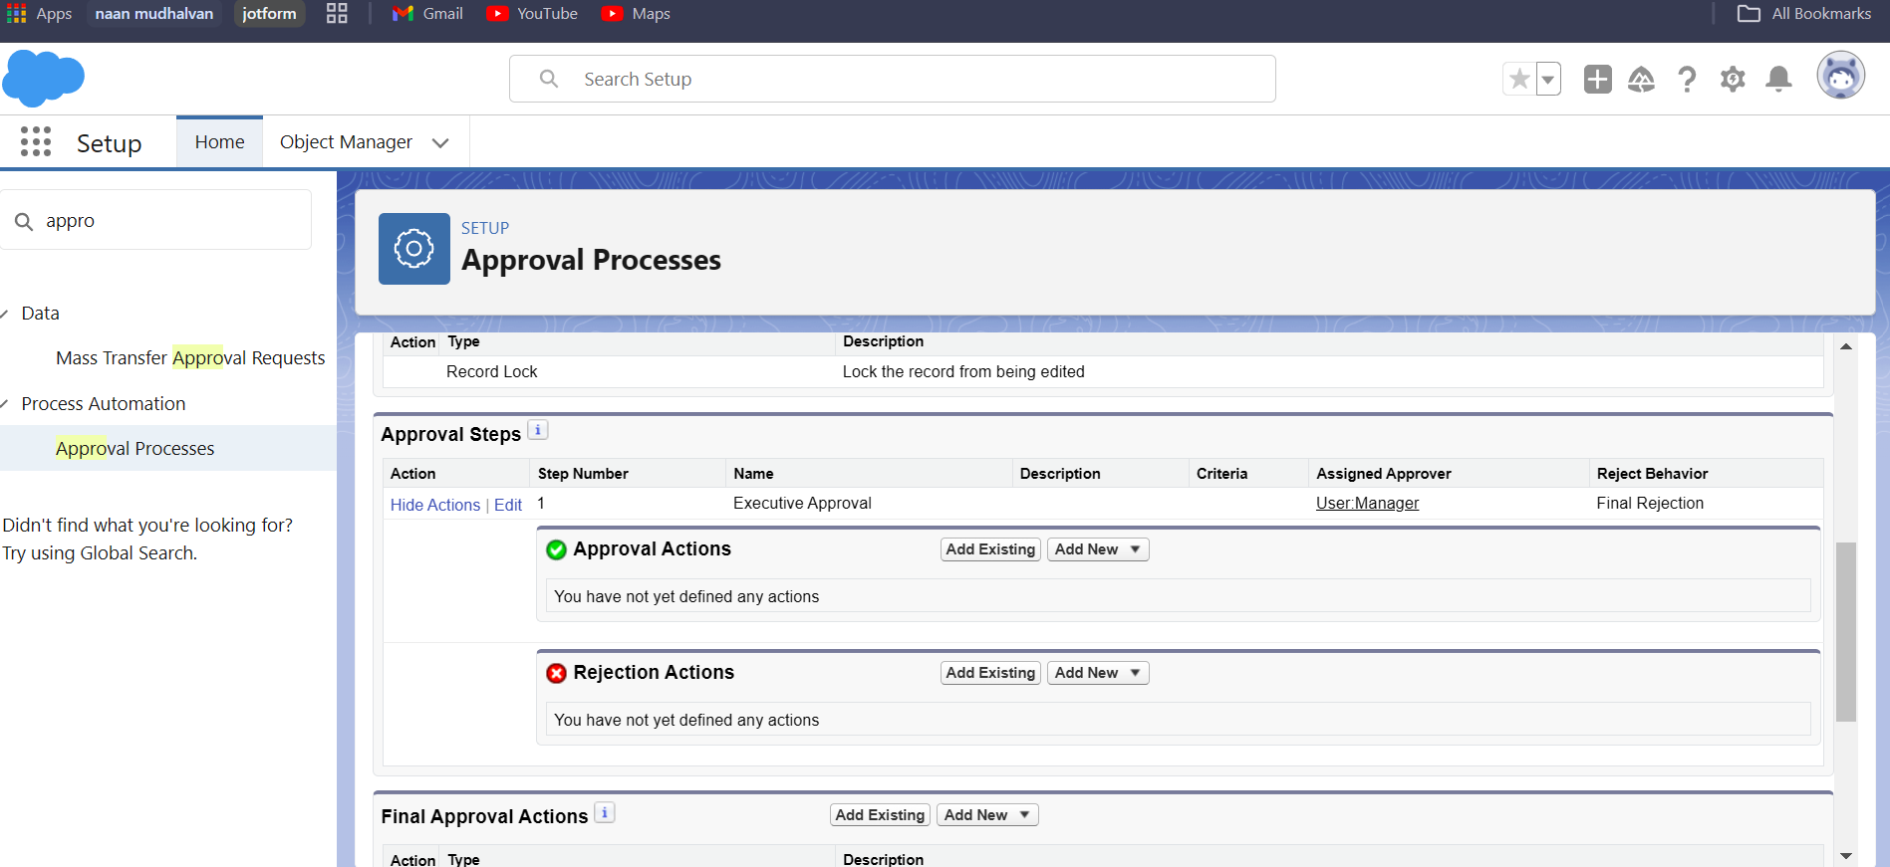

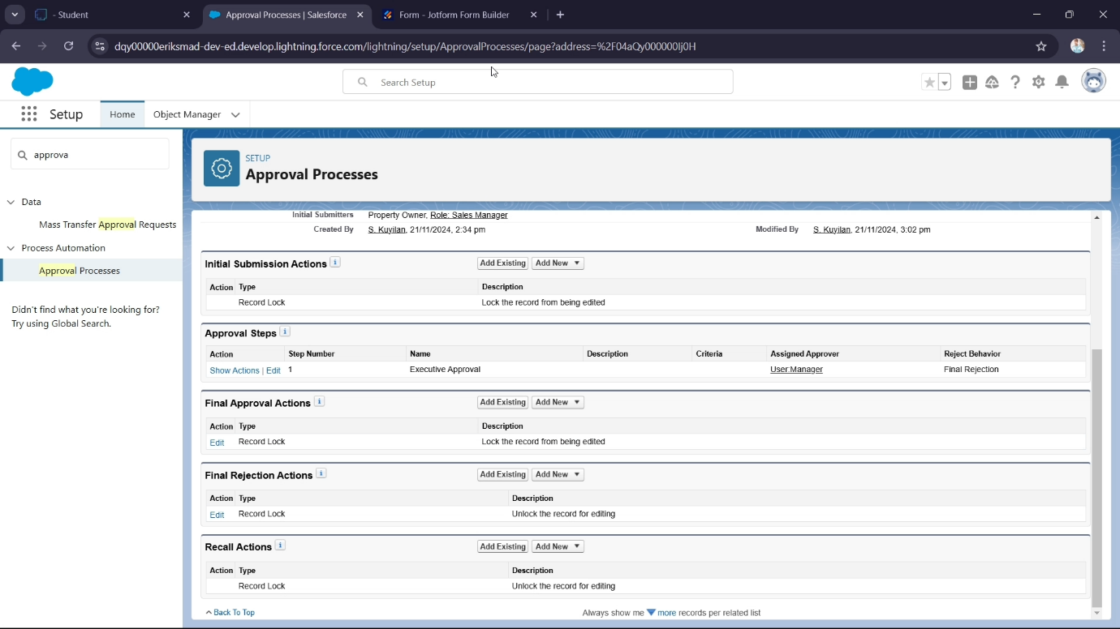

**Task 8:**

**Create a Record trigger flow to submit the Approval Process Automatically.**

Automatically submit the approval process when a property record is created.

● **Activity**:

a. Develop a Record Trigger Flow that triggers when a new property record is created and submits the record for approval.

**Task create objective:**

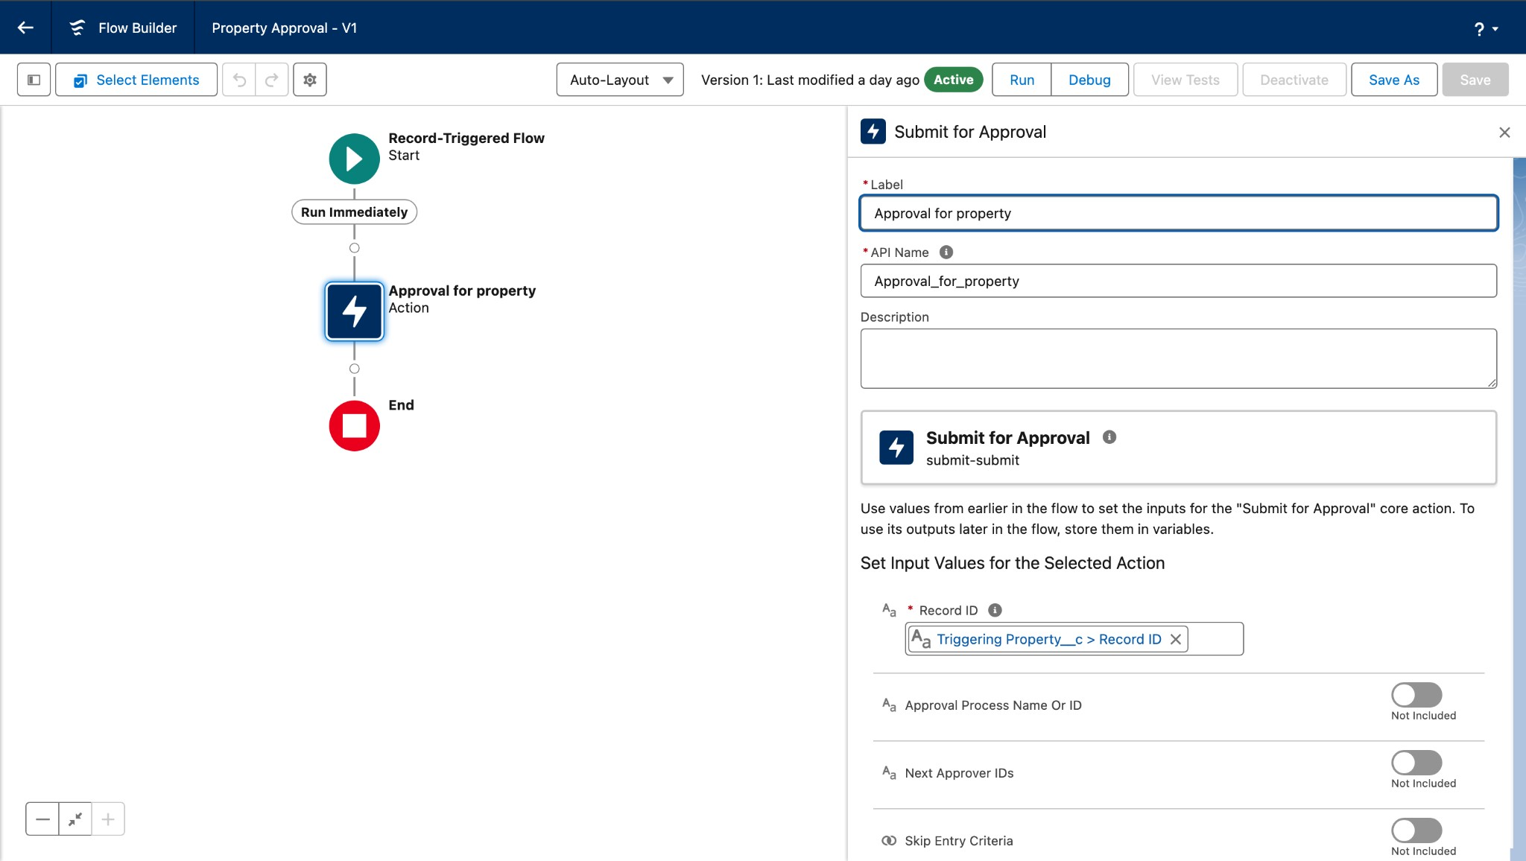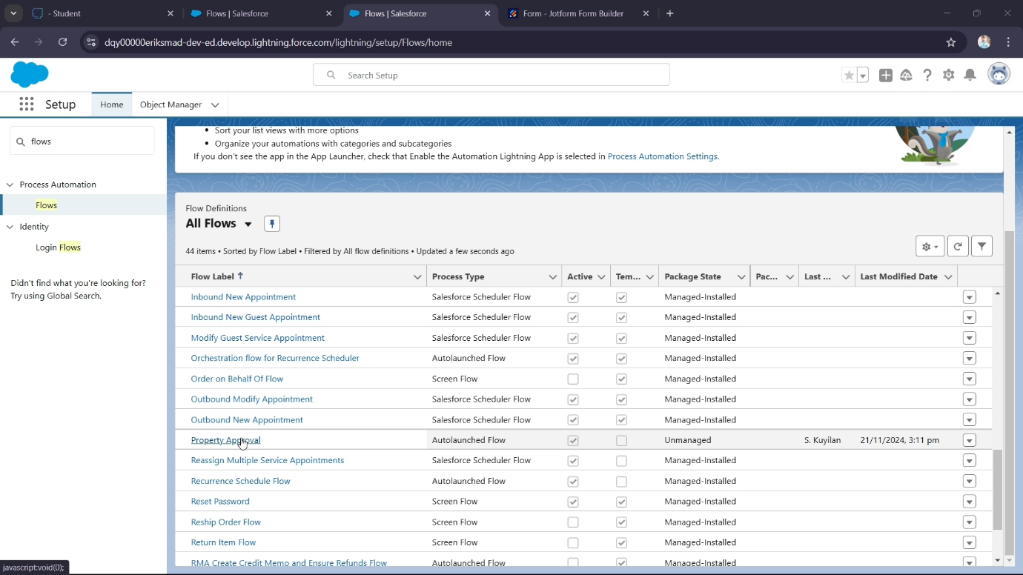

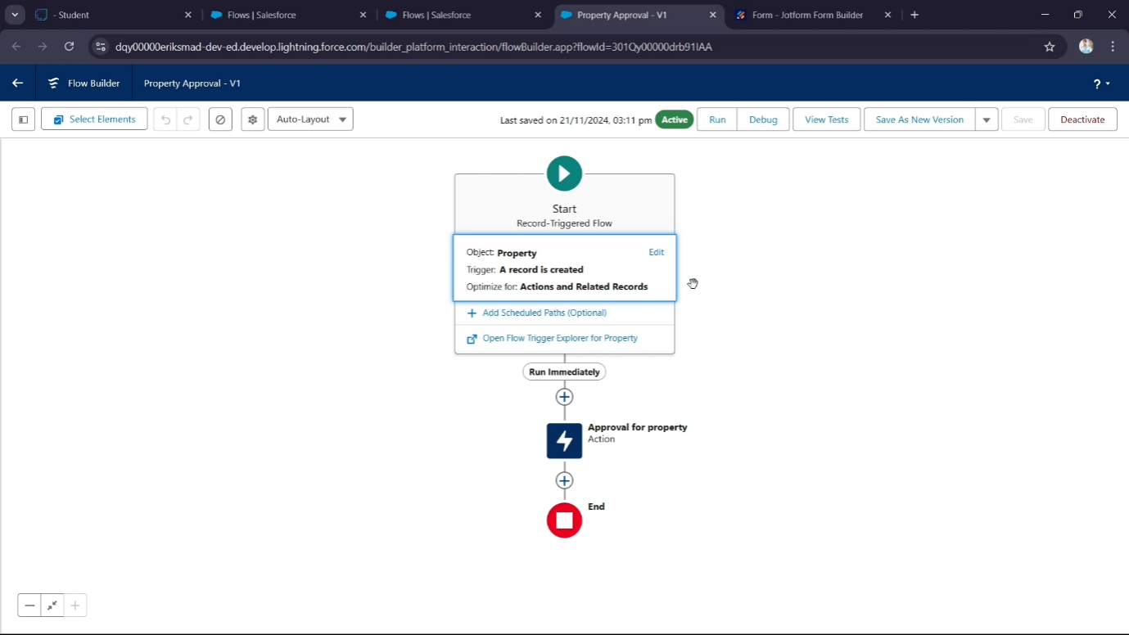

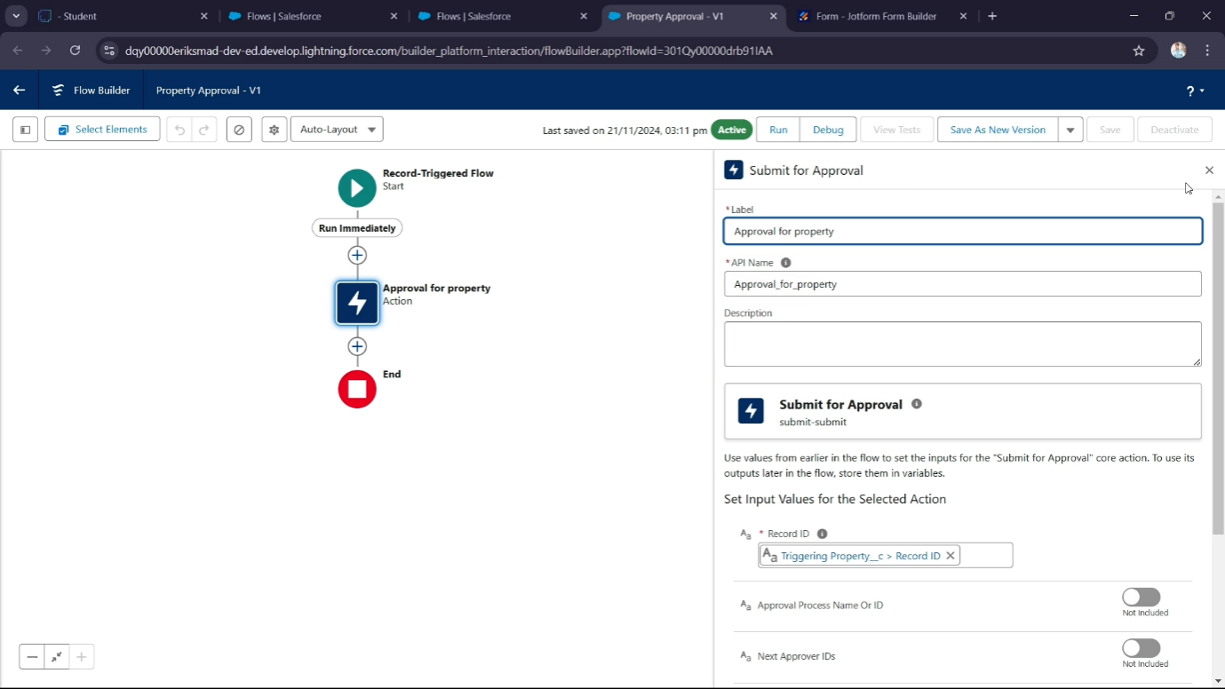

**Task 9: Create an App Page**

Build an app page for property search functionality.

● **Activity**:

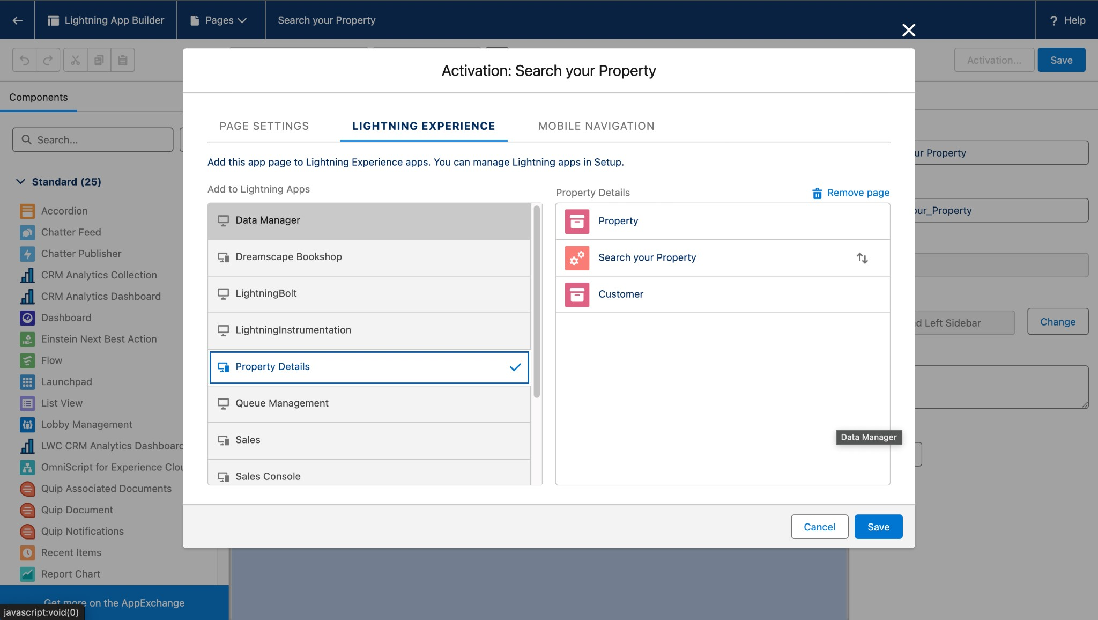a. Create an app page labeled "Search Your Property" and add it to the Property Details app.

**Task 10: Create Objective**: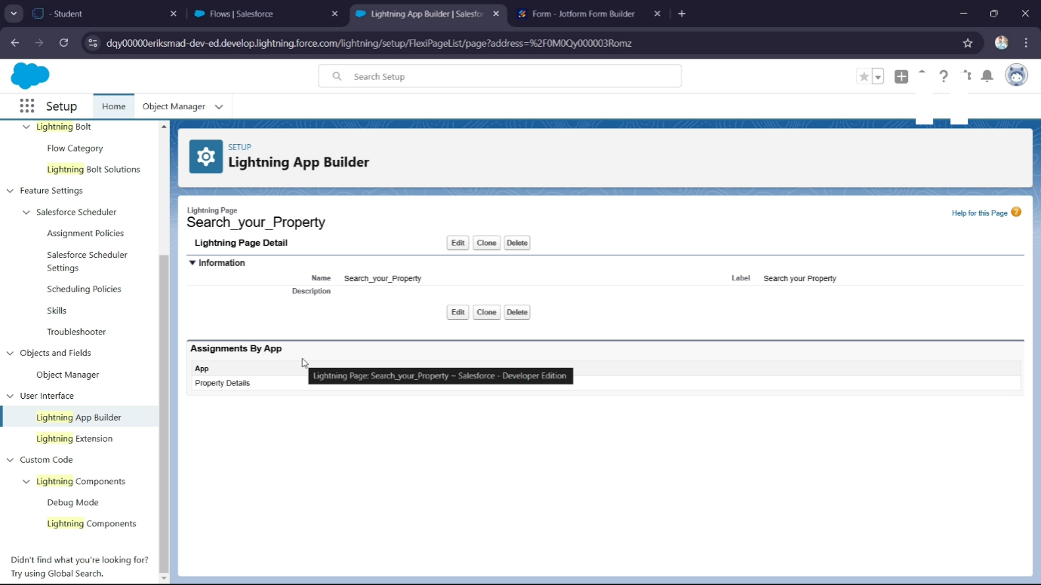

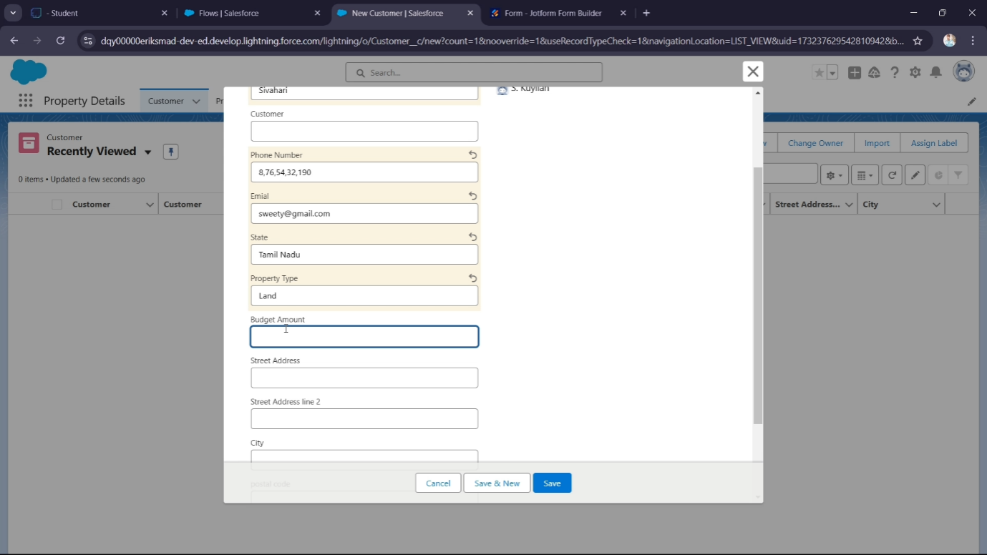

**Task 11:**

**Create a LWC Component**

### a Lightning Web Component (LWC)

Develop an LWC component to manage property access for verified and

unverified customers.

● **Activity**:

a. Develop the LWC component with Apex logic to handle property visibility based

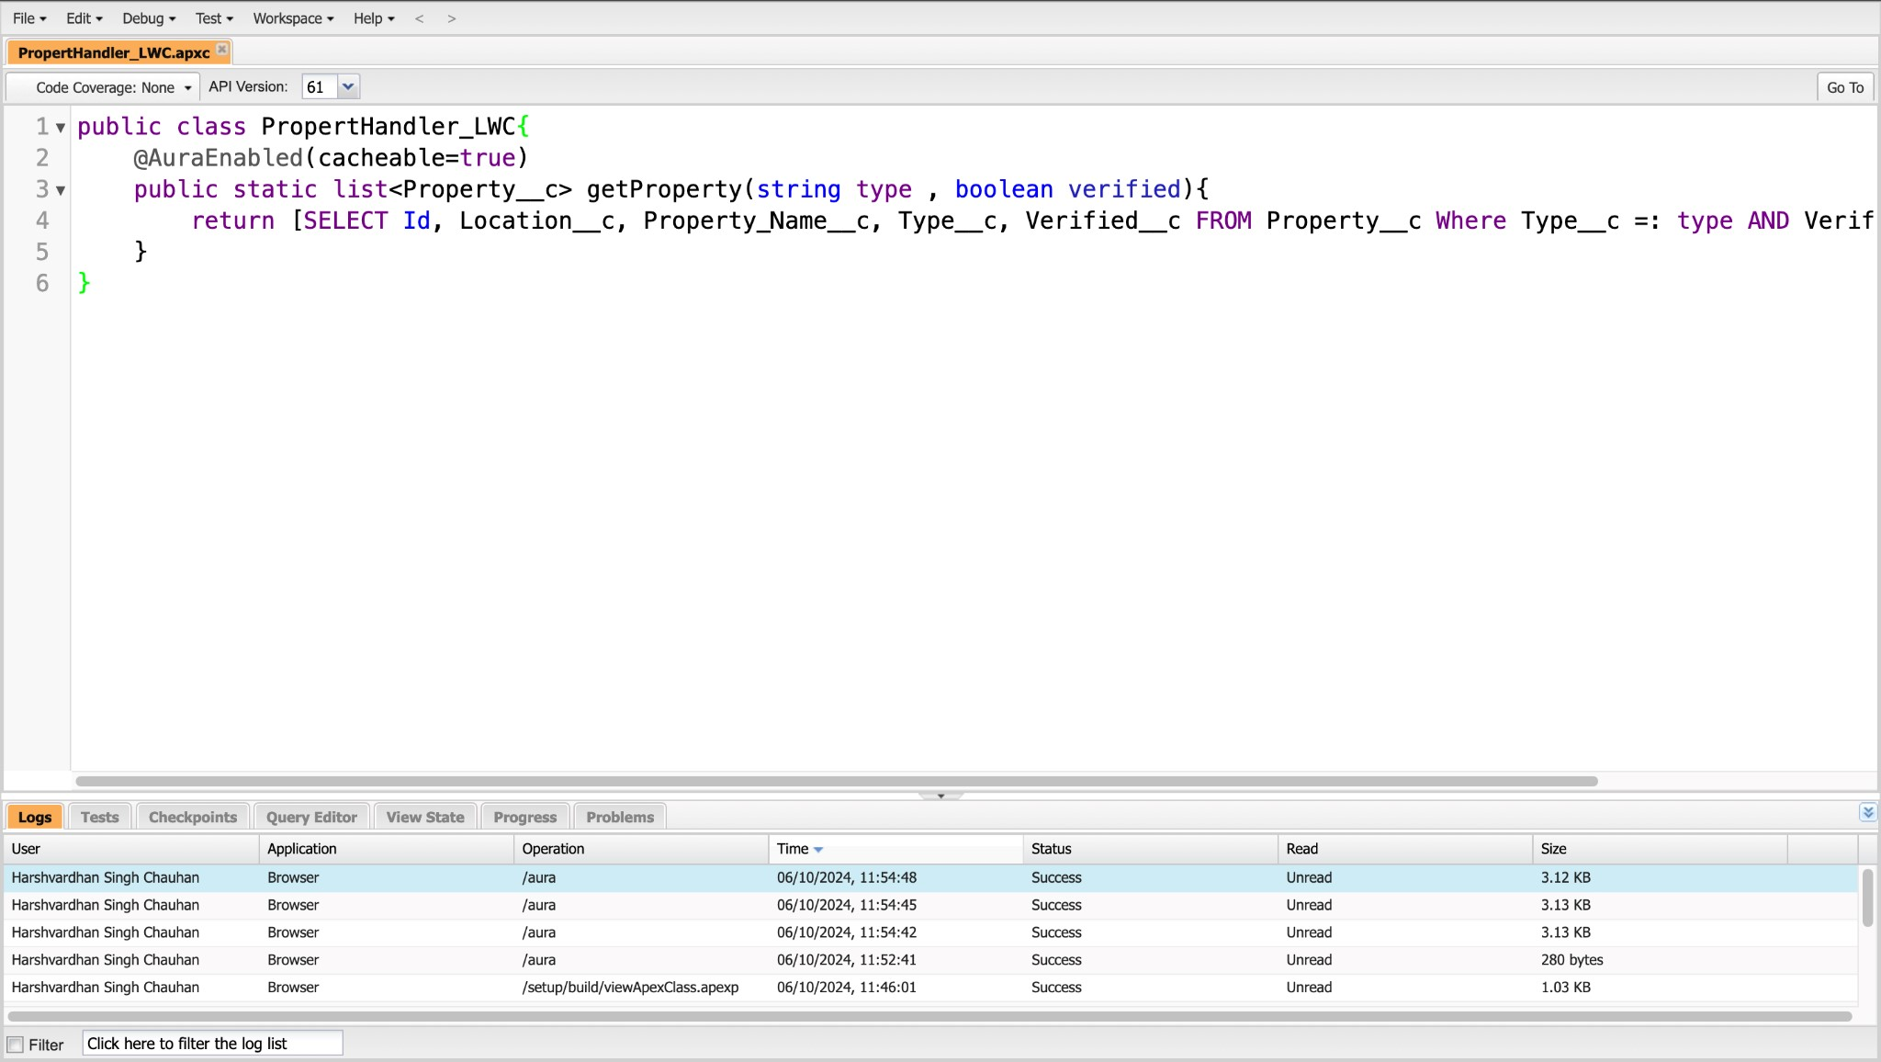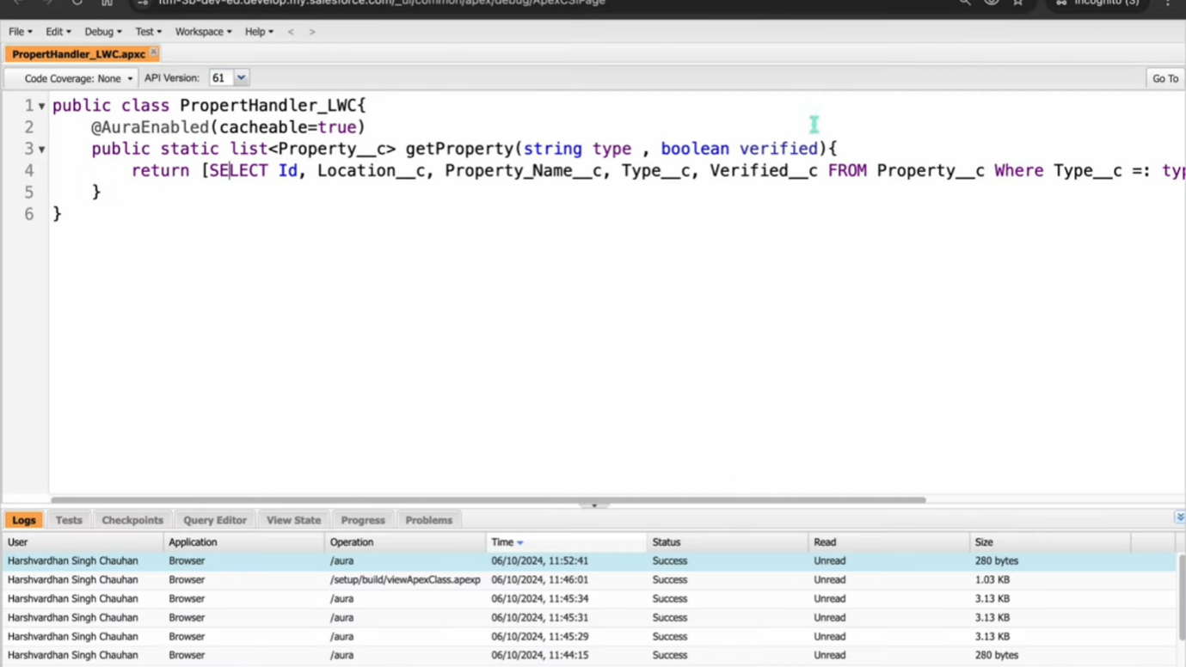

**Task 12: Create Objective**:

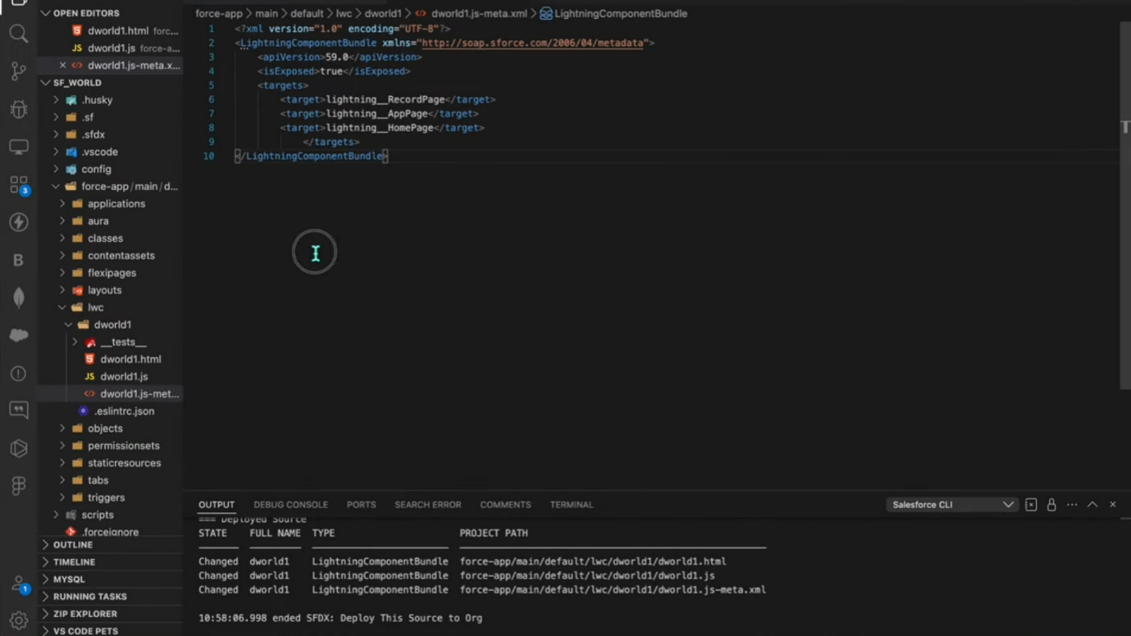

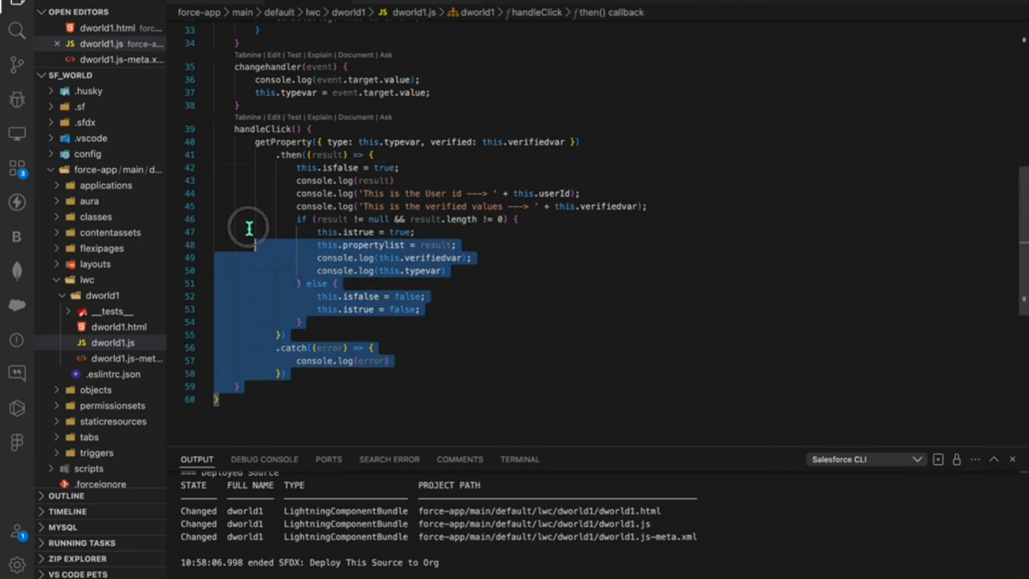

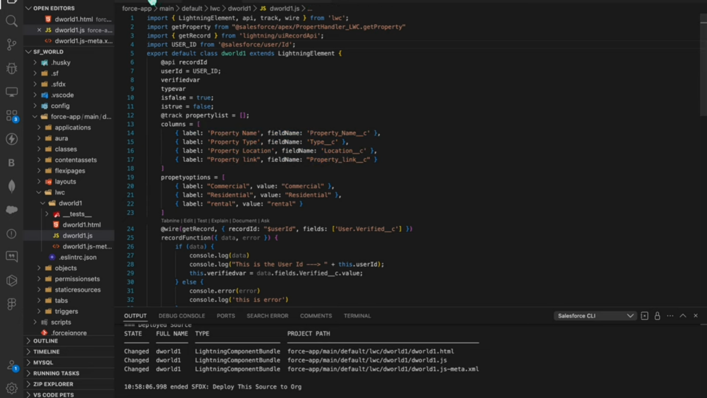

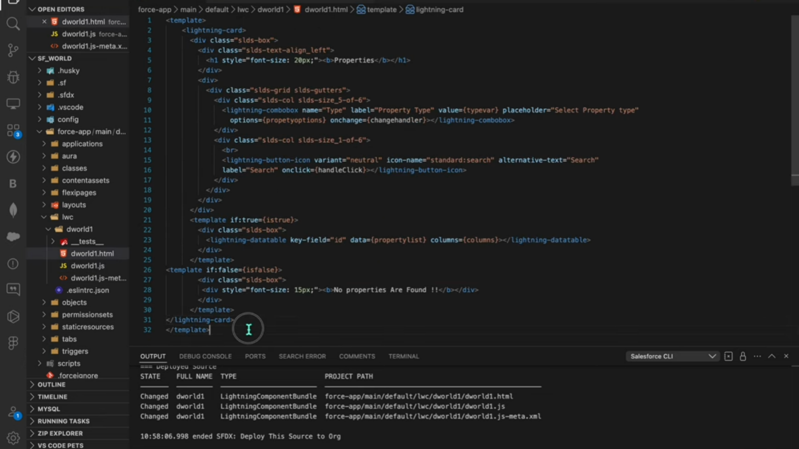

**Step 13: Drag this Component to your App Page**

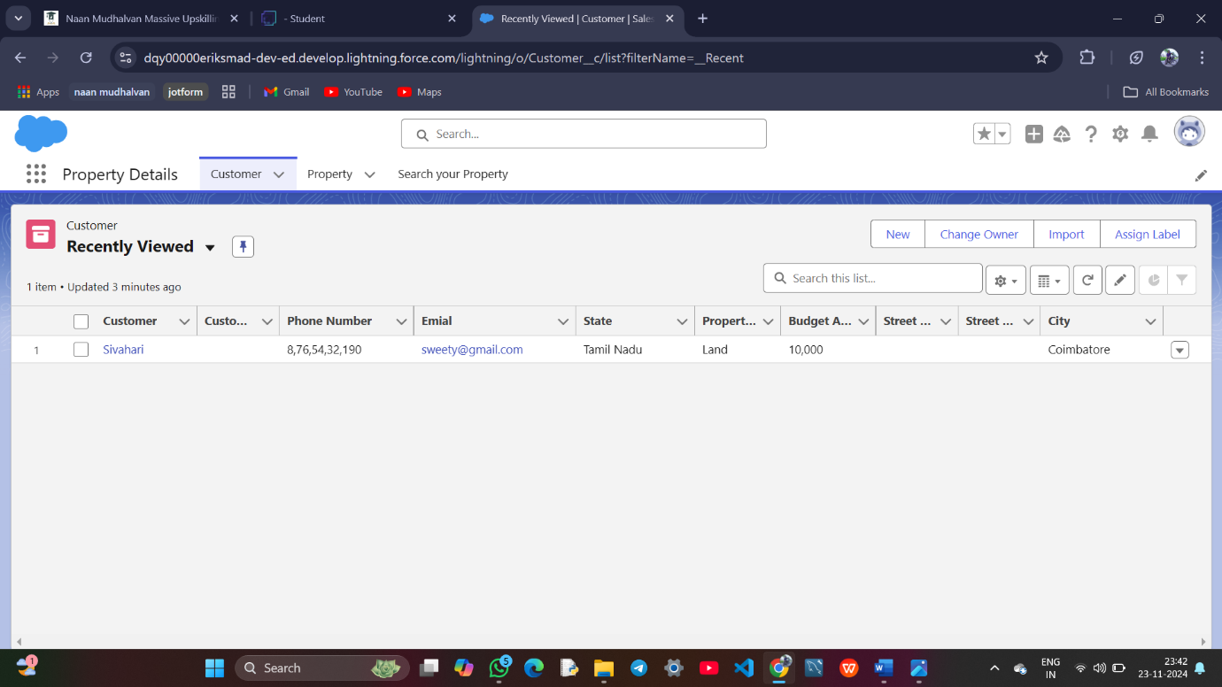

**Task 14: Give Access of Apex Classes to Profiles**

### Task 14: Assign Apex Class Access to Profiles

**Objective**: Set appropriate security access to Apex classes for necessary profiles.

● **Activity**:

a. Assign access to the Apex class PropertyHandler_LWC to both Manager and Customer profiles.

